**Communism – FINAL DELIVERABLE**

https://github.com/rockaflacka47/Communism/

6 DEC 2017

|  |  |  |
| --- | --- | --- |
| Name | GitHub | Title |
| Conor Lamb | Pere5troika | -- |
| Dave Rocker | rockaflacka47 | -- |
| Signe Ruprecht | SigneRuprecht | Scrum Master |
| Dalton Scharff | daltonscharff | -- |

# User Story Task Network

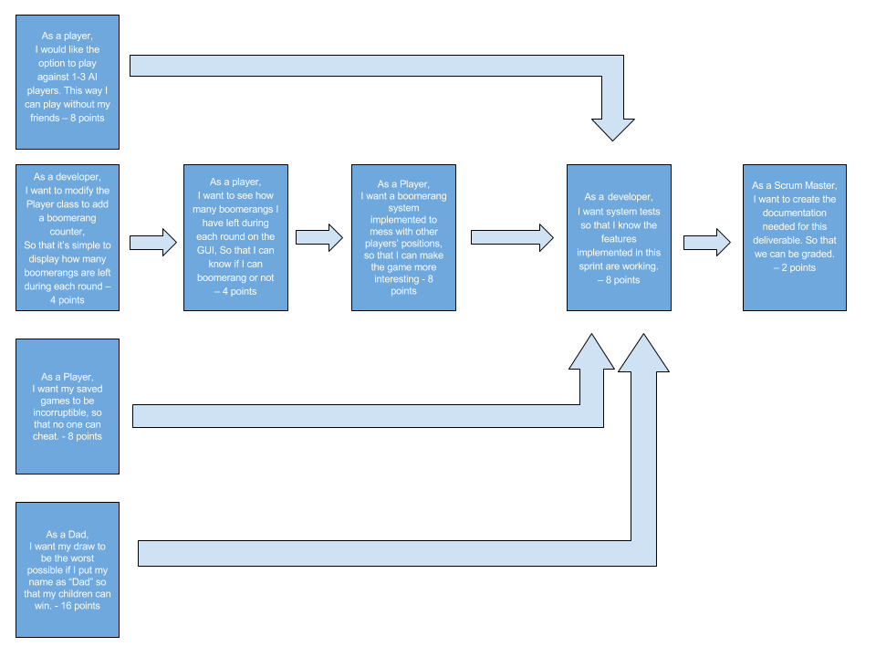

# User Story Assignment

**Conor:**

As a Player, I want my saved games to be incorruptible, so that no one can cheat. – 8 points

As a Developer, I want system tests so that I know the features implemented in this sprint are working. – 8 points

**Dalton:**

As a Developer, I want to modify the Player class to add a boomerang counter, so that its simple to display how many boomerangs are left during each round. – 4 points

As a Player, I want to see how many boomerangs I have left during each round on the GUI, so that I can know if I can boomerang or not. – 4 points

As a Player, I want a boomerang system implemented to mess with other players’ positions, so that the game is more interesting. – 8 points

As a Developer, I want system tests so that I know the features implemented in this sprint are working. – 8 points

**David:**

As a player/father, I want my draw to be the worst possible if I put my name as dad, so that my child/children can win. – 16 points

**Signe:**

As a Scrum Master, I want to create the documentation needed for this deliverable, so that we can get graded. – 2 points

As a Player, I would like the option to play against 1-3 AI players. This way I can play without my friends. – 8 points

As a Developer, I want system tests so that I know the features implemented in this sprint are working. – 8 points